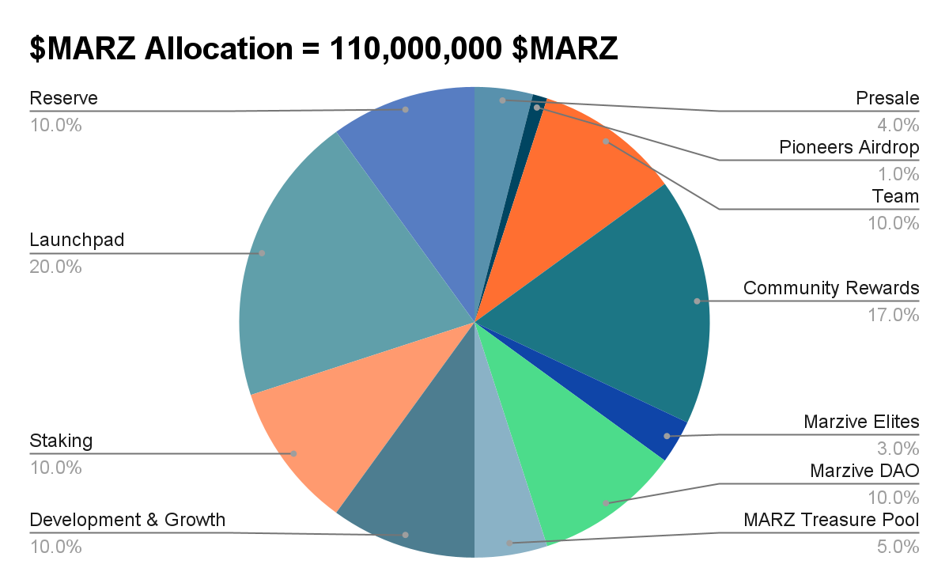

$MARZ Allocation
Total Coin Supply = 110,000,000 $MARZ

Presale = 4% (Unlocked immediately to purchase $MZS)
- Presale 1 [Private] = 1% @ $0.05
- Presale 2 [Private] = 1% @ $0.1
- Presale 3 [Public] = 1% @ $0.5
- Presale 4 [Public] = 1% @ $1

Pioneers Airdrop (ITO) = 1% ($MARZ10 will be sent to the first 100,000 verified wallets(with the Pioneer NFT), unlocked after the end of Season 1)

Team = 10%

Individuals- (Vesting: 1% unlocks every year for 5 years)

Team Bonus- (Vesting: 0.5% unlocks every year for 10 years)

Community Rewards = 17% (1.7% unlocked per season over 10 seasons)

Marzive Elites = 3% (0.3% unlocked at the end of each season for 10 seasons )

MarziveDAO = 10% (Locked, gradual unlock based on $MARZ price milestones)
- Unlocks 20% at $10
- Unlocks 30% at $100
- Unlocks 50% at $1000

MARZ Treasure Pool = 5% (0.5% unlocked each season for 10 seasons)

Development & Growth = 10% (To be allocated as needed for ecosystem expansion and upgrades)

Staking = 10% (Distributed to stakers as rewards over time)

Launchpad = 20% (Investing in 100 Web3 projects, unlocking 2% per season for 10 seasons)

Reserve = 10% (Allocated for partnerships, grants, ecosystem development, and operations, with flexible unlocks as needed)

Tokenomics

Total Supply = 110M
Marzive DAO = 10%
Presale = 4%
Pre-season Airdrop = 1%
Community = 17%
Marzive Elites = 3%
Team = 1010%
Marzive Treasure Pool = 5%
Staking = 10%
Development = 100%
Launchpad = 20%
Reserve = 10%

Roadmap
1st - 3rd Quarter of 2025
Marzive Website - done
MARZ token - $MARZ done
MZS token - $MZS done
Marzive Team - In process
Pre-season 1 (Marzive Mini App)
Presale
Listing
Marzive Mobile App
Marz Hunts (Season 1)

Season 1
Initial lock = 90%
In circulation = 10%
Airdrop Pool = $MARZ 1,870,000
MARZ Treasure Pool = $MARZ 5000
Total Number of Players = 100K [+=50K]
Time Duration = 3 months
Stake Duration = 1 month

Season 2
Initial lock = 80%
In circulation = less than or equal to 20%
Airdrop Pool = $MARZ 1,870,000
MARZ Treasure Pool = $MARZ 3,800
Total Number of Players = 200K[+=100K]
Time Duration = 4 months
Stake Duration = 2 months

Season 3
Initial lock = 70% [MARZ Treasure Pool]
In circulation = less than or equal to 30%
Airdrop Pool = $MARZ 1,870,000
MARZ Treasure Pool = $MARZ 3,000
Total Number of Players = 300K[+=150K]
Time Duration = 5 months
Stake Duration = 3 months

Season 4
Initial lock = 60% [$MARZ Treasure Pool]
In circulation = less than or equal to 40%
Airdrop Pool = $MARZ 1,870,000
MARZ Treasure Pool = $MARZ 2,500
Total Number of Players = 400K[+=200K]
Time Duration = 6 months
Stake Duration = 4 months

Season 5
Initial lock = 50% [$MARZ Treasure Pool]
In circulation = less than or equal to 50%
Airdrop Pool = $MARZ 1,870,000
MARZ Treasure Pool = $MARZ 2,180
Total Number of Players = 500K[+=250K]
Time Duration = 7 months
Stake Duration = 5 months

Season 6
Initial lock = 40% [$MARZ Treasure Pool]
In circulation = less than or equal to 60%
Airdrop Pool = $MARZ 1,870,000
MARZ Treasure Pool = $MARZ 1,900
Total Number of Players = 600K[+=300K]
Time Duration = 8 months
Stake Duration = 6 months

Season 7
Initial lock = 30% [$MARZ Treasure Pool]
In circulation = less than or equal to 70%
Airdrop Pool = $MARZ 1,870,000
MARZ Treasure Pool = $MARZ 1,690
Total Number of Players = 700K [+=350K]
Time Duration = 9 months
Stake Duration = 7 months

Season 8
Initial lock = 20% [$MARZ Treasure Pool]
In circulation = less than or equal to 80%
Airdrop Pool = $MARZ 1,870,000
MARZ Treasure Pool = $MARZ 1,520
Total Number of Players = 800K[+=400K]
Time Duration = 10 months
Stake Duration = 8 months

Season 9
Initial lock = 10% [$MARZ Treasure Pool]
In circulation = less than or equal to 90%
Airdrop Pool = $MARZ 1,870,000
MARZ Treasure Pool = $MARZ 1,380
Total Number of Players = 900K[+=450K]
Time Duration = 11 months
Stake Duration = 9 months

Season 10
Initial lock = Zero lock [$MARZ Treasure Pool]
In circulation = less than or equal to 100%
Airdrop Pool = $MARZ 1,870,000
MARZ Treasure Pool = $MARZ 1,270
Total Number of Players = 1M[+=500K]
Time Duration = 12 months
Stake Duration = 10 months

MZC Allocation
The currency for in-game and Marzive Club activities.

Marz Cash Total Supply = 1 Billion $MZC (100% Airdrop)
Season 1 = 100 Million $MZC
Season 2 = 100 Million $MZC
Season 3 = 100 Million $MZC
Season 4 = 100 Million $MZC
Season 5 = 100 Million $MZC
Season 6 = 100 Million $MZC
Season 7 = 100 Million $MZC
Season 8 = 100 Million $MZC
Season 9 = 100 Million $MZC
Season 10 = 100 Million $MZC

Note: Each season is capped @ 100 Million MARZ Cash. Any $MZC not claimed during any pre-season will be burned out of circulation for the season.

Early Pioneers [ 1-1K ]
- Marz Cash = $MZC10,000
- Referral Bonus = $MZC1,000

Mid-term Pioneers [ >1K<=5K ]
- Marz Cash = $MZC5,000
- Referral Bonus = $MZC500

Late Pioneers [ >5K<=10k ]
- MARZ Cash = $MZC1,000
- Referral Bonus = $MZC100

Normal Users [ >10K<=100M ]
- MARZ Cash = $MZC100
- Referral Bonus = $MZC10

Marz Cash will be used in-game to purchase Marzive items. Every $MZC unclaimed during pre-season will be burnt. The value of Marz Cash increases with respect to its burning mechanism.

A P2P section will be in the Marzive Store on the Marzive application where Marzive users can exchange their $MZC for a good price of $MARZ.

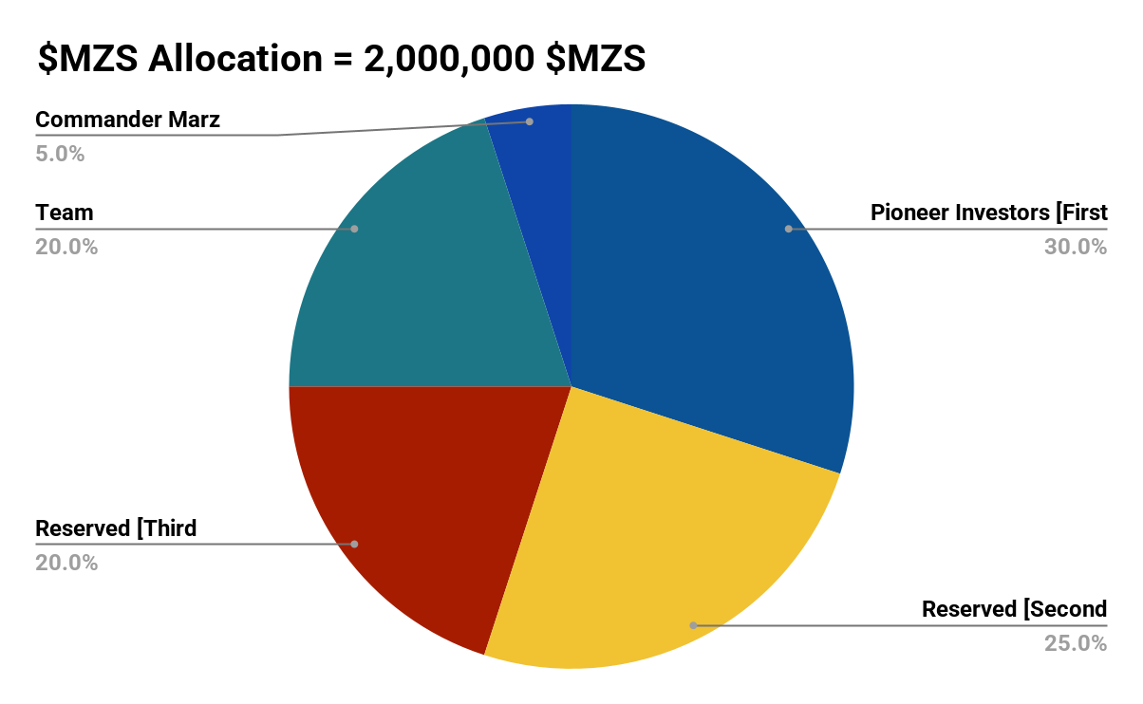
$MZS (Marzive Shares) Allocation

Total Coin Supply = 2,000,000 $MZS

1 $MZS = 50 $MARZ Forever

Marzive Investors = 1,400,000 $MZS [65% for Marzive investors]

Commander Marz = 100,000 $MZS [5% reserved for commander Marz]
Team = 200,000 $MZS [25% of total supply is distributed to team members]
Marzive Elites = 100,000 $MZS [5% of total supply is distributed to Marzive Elites]

Smart Contract: If you hold $MZS for more than 4 months, you can claim the Revenue funds from the various web3 projects you invested in.

Investors Package

Investors Starter 1
[1 Marzive shares]
1 Marzive Share = 1 $MZS
1 $MZS = $MARZ 50

Investors Starter 2
[5 Marzive shares]
1 Marzive Share = 1 $MZS
5 $MZS = $MARZ 250

Investors Starter 3
[10 Marzive shares]
1 Marzive Share = 1 $MZS
10 $MZS = $MARZ 500

Investors Special
[50 Marzive shares] + 1 $MZS
1 Marzive Share = 1 $MZS
50 $MZS = $MARZ 2500

Investors Special Max
[100 Marzive shares] + 2 $MZS
1 Marzive Share = 1 $MZS
100 $MZS = $MARZ 5000

Note:

Each member of the Team is given 0.1% of Team Allocation for $MZS for 5 years.

Each Elite is given 0.0001% of Marzive Elite Allocation for $MZS for 5 years.

Testnet Tokens {Pre-Season 1}
Total Coin Supply = 2,000,000 $MZS test tokens
Total Coin Supply = 1,100,000 $MARZ test tokens [1% of the Real token total supply]
Total Pioneers MAX = 1,000,000
Eligible Players for Season 1 = 100k
Total Marzive Elite-NFT Badge = 1,000
First 100 Marzive Elites = $10
Task 1
-Follow all our social media handles and interact with almost all our spaces.
Task 2
-Invite minimum friends of 5

Task 3
-Create your Marzive Base wallet.
-Generate your Marzive ID

-Join the Marzive Testnet (Using your Marzive ID)

Task 4 = Transfer $MARZ test token to other parties on the base network using your $MARZ wallet address.
Task 5 = Host your own space about what Marzive is building and invite a minimum of 100 people or above to talk about the topic you have set for the space. Ensure you tag Marzive to see your post, and ensure the post is recorded. [Tips: the space should be 100 and above to be qualified for a Marzive Elite Badge.
Highest Pioneers Rewards

-At the middle of the pre-season, the first 100,000 Marz pioneer will be sent an invitation to mints a free $MARZ pioneer NFT.

-At the end of pre-season 1, the first 950 pioneers with the highest MP will get an invitation to mint a free Marzive Elite NFT.

$10,000 in reward goes to the top 100 Marzive pioneers with the highest MP

1st-3rd gets $350 each
4th-10th gets $200 each
11th-50th gets $100 each
51st-100th gets $50 each
What is the Marzive Elite-NFT Badge?
The Marzive Elite-NFT Badge is a unique digital collectible that represents an exclusive status within the Marzive ecosystem. It serves as both a reward and a symbol of dedication, showcasing your commitment and active participation in building the future of Marzive. In other words, having a Marzive Elite-NFT badge makes one an influencer in the marzive ecosystem.

Key Features of the Marzive Elite-NFT Badge
- Exclusive Recognition:
  - Reserved for the top 1,000 most active Marzive pioneers who have proven their dedication by completing key tasks and contributing to the ecosystem's development during each Marzive pre-season.
- Access to Elite Opportunities:
  - Badge holders may gain priority access to special events, governance voting, and early opportunities in the Marzive DAO.
  - Holders can influence the future development of Marzive through direct interaction with the DAO.
- Minting Process:
  - The badge is minted exclusively for pioneers who qualify by:
    - Completing the listed tasks (e.g., social engagement, wallet verification, hosting spaces).
    - Being among the most active contributors with the highest MP.
- Proof of Contribution:
  - The badge is a permanent blockchain asset that serves as evidence of your support and contribution to growing the Marzive ecosystem during its preseason phases.
- Enhanced Reputation:
  - Holding the Marzive Elite-NFT Badge sets you apart as a key contributor and influencer to the ecosystem, elevating your status within the community.
- Staking Asset:
  - With the Marzive Elite-NFT, the Marzive player can get APY up to 50%, depending how long he or she has staked.
- Monthly Stipend:
  - With the Marzive DAO, Marzive Elites are given tokens monthly for their contributions in growing the Marzive ecosystem.

Why Should You Aim for the Marzive Elite-NFT Badge?
- Prestige: Be recognized as one of the founding contributors and influencers to the Marzive ecosystem.
- Utility: The badge is more than just a collectible; it provides access to exclusive governance roles and potential rewards in the Marzive DAO.
- Community Leadership: Lead discussions and influence the direction of Web3 innovation with your elevated status.
- Limited Supply: With only 10,000 badges available, it’s a rare and valuable token of recognition.

How to Qualify for the Badge?
To mint the Marzive Elite-NFT Badge, ensure you:
- Complete Tasks: Engage actively by completing all tasks, including wallet transfers and hosting meaningful Web3 discussions.
- Be among the Top 1,000 active Marzive contributors: Your activity level and contributions will determine your eligibility to mint the badge.
Token Economics Management
Burn, Buyback, and Stake Mechanism

-On-application Zero transaction fee
-Off-application Transaction Fees Breakdown (20%)
- 20% Burn (4%):
  - Reduces circulating supply, making $MARZ scarcer and increasing its value over time.
- 30% re-Staked (6%):
  - Automatically staked into the user’s staking wallet.
  - Staking rewards are capped at a fixed 10% APY for 1 year, ensuring fairness and sustainability.
  - Users save for the future effortlessly, as staking happens automatically with every transaction.
- 30% Buyback (6%):
  - Marzive uses this portion of transaction fees to buy back $MZC tokens.
  - Demonstrates Marzive’s commitment to the ecosystem while stabilizing token value.
- 5% referral fee (1%)
- 10% Educational Campaign (0.15%):
  - Marzive Academy will be created to teach people web3 skills which they can now utilise in the Marzive Gig Economy.
- 5% Marzive fee
The status of your Rank in Marzive will depend on how long, you grow your staking pool, originally its takes 1 year at default but when you grow in Rank, you can readjust it to 2 months, 3 months or even 6 months before you withdraw your staked asset.
Seasonal Lock Periods:
- Staked assets can only be withdrawn after specific lock periods, depending on the season, encouraging long-term commitment to the ecosystem.
All staked tokens remain locked for a season before withdrawal is allowed:
- Season 1: Staking lock period = 1 month.
- Season 2: Staking lock period = 2 months.
- Season 3: Staking lock period = 3 months, and so on.
Other forms of staking come when you connect with someone with a Marzive Elite-NFT badge, so depending on the person you connect with will depend on the APY you get for the period of time you connect with their badge.

